Project Design Document

1. Design Intent
- An interactive experience centered around a chameleon inspired by the one from Tangled
- Its for users who like to integrate tech with whimsy
- It gives clarity on how simple toys work and learn about integration of technology with material manipulation


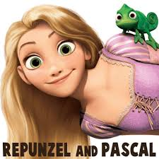
2. Inspiration & References

- Joint mechanisms found in MSL lab

3. User Journey
Step-by-step experience of the user:
- User comes close to IR sensor, servo motor moves on readings coming from the IR, its head “shy-s away” (tilts away)
- User shakes its hand, touch sensors reads values < 200 and makes the servo motor wag its tail
- User places something near the colour detector module, reads rgb values and makes the neopixel glow the same rgb values

4. Success Criteria
Define measurable success:
- IR sensor detects from a sufficient distance, touch sensor should read the values properly, colour detector should detect the correct rgb values, neopixel should showcase the correct rgb values, code should run smoothly, don’t fry esp32 or power module
- Interactive, easy flow of direction

5. System Overview

- the chameleon wags its tail in response to the touch, moves its head to acknowledge the person, and changes its body color to match the object.
- Head moving, hand shaking, tail wagging, neopixel giving camouflage effect

6. High-Level Block Diagram

7. Input / Output Mapping
Input | Process | Output
IR Sensor, Color Detector, Touch Pin | ESP32 running MicroPython | Head Servo, Tail Servo, Neopixel

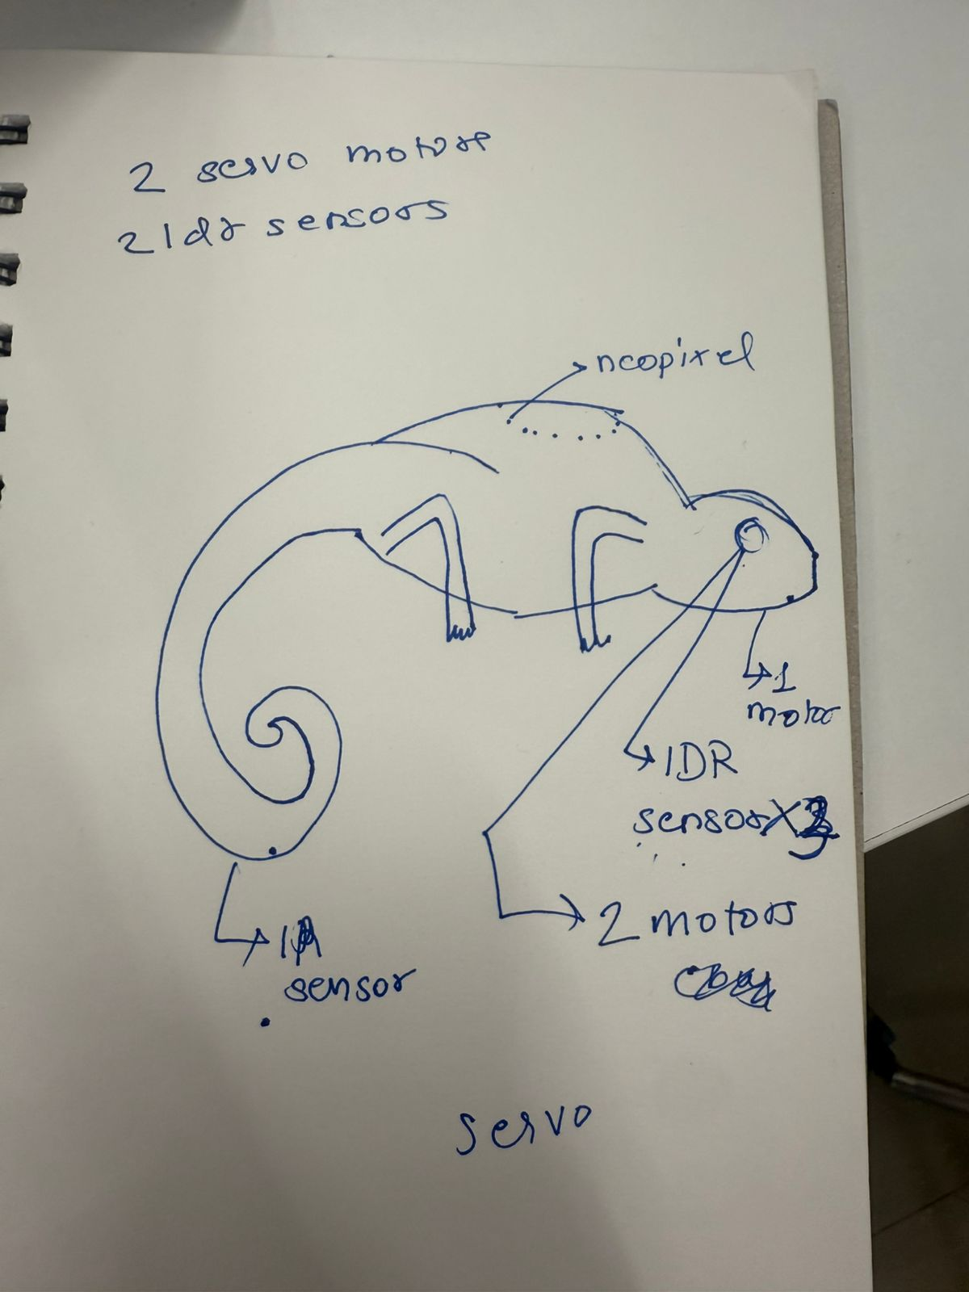

8. Sketches & Concepts
- Hand sketches / early ideas
- Iterations

9. Final System Architecture (Labelled)
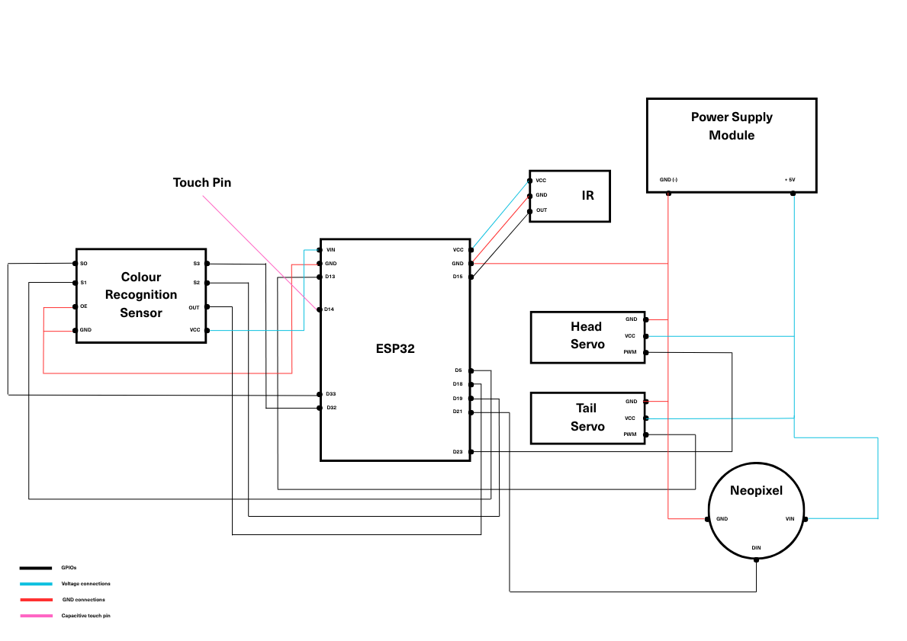
👉 Clear diagram showing all components and connections

